**CHAPTER 2**

**LITERATURE REVIEW**

A literature review surveys books, scholarly articles, and any other sources relevant to a particular issue, area of research, or theory, and by so doing, provides a description, summary and critical evaluation of these works in relation to the research problem being investigated. Literature reviews are designed to provide an overview of sources you have explored while researching a particular topic and to demonstrate to your readers how your research fits within a larger field of study.

A literature review may consist of simply a summary of key sources, but in the social sciences, a literature review usually has an organizational pattern and combines both summary and synthesis, often within specific conceptual categories. A summary is a recap of the important information of the source, but a synthesis is a re-organization, or a reshuffling, of that information in a way that informs how you are planning to investigate a research problem. The analytical features of a literature review might:

* Give a new interpretation of old material or combine new with old interpretations,
* Trace the intellectual progression of the field, including major debates,
* Depending on the situation, evaluate the sources and advise the reader on the most pertinent or relevant research, or
* Usually in the conclusion of a literature review, identify where gaps exist in how a problem has been researched to date.

The purpose of a literature review is to:

* Place each work in the context of its contribution to understanding the research problem being studied.
* Describe the relationship of each work to the others under consideration.
* Identify new ways to interpret prior research.
* Reveal any gaps that exist in the literature.
* Resolve conflicts amongst seemingly contradictory previous studied
* Identify areas of prior scholarship to prevent duplication of effort.
* Point the way in fulfilling a need for additional research.

**2.1 AI-facilitated Coating Corrosion Assessment System for Productivity Enhancement [1]**

Assessment of CBC is the major aspect in coating failure management. Subjective assessment methods cause unnecessary maintenance cost and higher risk of failure. To improve efficiency and productivity, an integrated coating breakdown and corrosion (CBC) assessment system is developed. This AI-facilitated CBC inspection system implements a deep transfer learning technique to automate CBC assessment, it includes a faster region-base convolutional neural network (faster R-CNN) architecture and a vgg19 model for deep transfer learning, an instance-aware semantic segmentation method is developed for CBC measurement and grading.

**Architecture:**

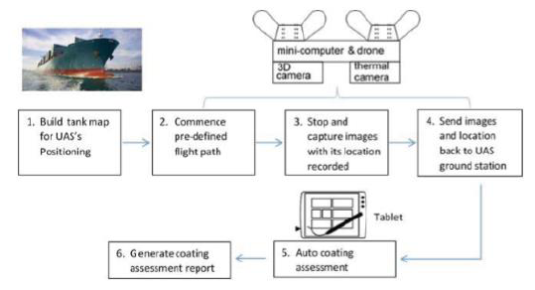

Figure 2.1: AI-facilitated drone inspection system for coating failure

Feature Extraction: Nineteen-layer deep learning network Vgg19 is used for feature extraction. The three categories of coating corrosion and breakdown are surface-based CBC, edge-based CBC and non-coating-failure. Feature Learning and Prediction: Deep transfer learning on convolution activation feature (TLCAF) network [6] is referred for feature extraction and learning. Feature Detection: Randomly generated bounding boxes are used to propose region-of-interest (ROI) for different categories of CBC prediction. The predicted CBC regions of interest are reconstructed with background removal.CBC Measurement: For CBC measurement, the extracted Hue, Saturation and Value (HSV) data is used to identify the possible pixel values for coating failure detection.

**2.2 Knowledge base system (KBS) applied on corrosion damage assessment on metallic structure pipes [2]**

This paper aims to outline a proposed knowledge base system (KBS) for the assessment of corrosive damage on metallic pipe conduits. KBS is developed by using two information sources available for assessing the corrosive damage of pipes which are mainly: expert knowledge and field data. In our knowledge, it’s a new method that assists the engineer in his task for assessing the degree of damage on metallic pipes, yielding therefore to a rational evaluation of the corrosive damage (hence the ECOR system) on metallic structures of pipeline, and permits to assign the damage degree on the structure qualitatively while using a ladder of indications representing the severity of each damage type(pitting, crater, weight loss and crack), regarding the priority of either repairing or replacing the metal piece. Furthermore, the analytic hierarchy process is implemented overall the system to determine whether the damage severity requires the engineer intervention in a systematic and rational way

**Architecture:**

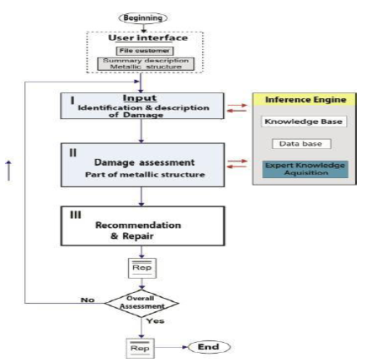

Figure 2.2: KBS applied on metallic structure pipe

The analytic hierarchization method (AHP) P is a method mainly considering the elements of problem as a body, and split up into a sub problem by using series of conclusive decisions to develop a hierarchical analytical operation, while its execution leads to a final matrix representing the general alternative priorities linked each one to the other. Damage assessment method presented above remains a tangible approach, which is elaborated by some experts weighing by indexes and responding to the knowledge of the exact relative importance of each indicator.

**2.3 Metaheuristic Optimized Edge Detection for Recognition of Concrete Wall Cracks: A Comparative Study on the Performances of Roberts, Prewitt, Canny, and Sobel Algorithms [3]**

Crack detection is a crucial task in the periodic survey of high-rise buildings and infrastructure. Manual survey is notorious for low productivity. This study is aimed at establishing an image processing-based method for detecting cracks on concrete wall surfaces in an automatic manner. The Roberts, Prewitt, Canny, and Sobel algorithms are employed as the edge detection methods for revealing the crack textures appearing in concrete walls. The median filtering and object leaning operations are used to enhance the image and facilitate the crack recognition outcome. Since the edge detectors, the median filter, and the object cleaning operation all require the appropriate selection of tuning parameters, this study relies on the differential flower pollination algorithm as a metaheuristic to optimize the image processing-based crack detection model. Experimental results point out that the newly constructed approach that employs the Prewitt algorithm can achieve a good prediction outcome with classification accuracy rate 89.95% and area under the curve 0.90. Therefore, the proposed metaheuristic optimized image processing approach can be a promising alternative for automatic recognition of cracks on the concrete wall.

**Architecture:**

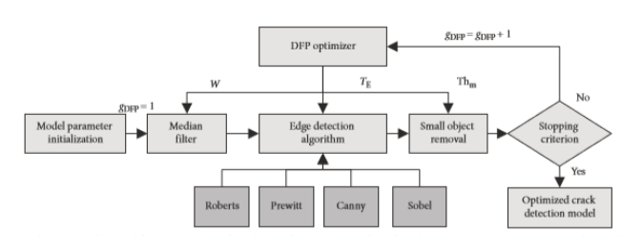

Figure 2.3: Model for recognition of cracks on the concrete wall surface

Roberts’s edge detection method first described by Roberts is as simple and fast algorithm for calculating the spatial gradient measurement on a digital image. Prewitt edge detection method also relies on two filters to estimate the derivatives of each location within an image. Sobel edge detection method widely employed method in image processing; this edge detector highlights edges by first smoothing the image before calculating the derivatives.

**2.4 Evaluation of deep learning approaches based on convolutional neural networks for corrosion detection [4]**

Robotic systems, such as unmanned aerial vehicles, paired with computer vision algorithms have the potential to perform autonomous damage detection that can significantly decrease inspection time and lead to more frequent and objective inspections. This study evaluates the use of convolutional neural networks for corrosion detection. A convolutional neural network learns the appropriate classification features that in traditional algorithms were hand-engineered. Eliminating the need for dependence on prior knowledge and human effort in designing features is a major advantage of convolutional neural networks. It is shown that one of the proposed convolutional neural networks significantly improves the computational time in contrast with state-of-the-art pertained convolutional neural networks while maintaining comparable performance for corrosion detection.

**Architecture:**

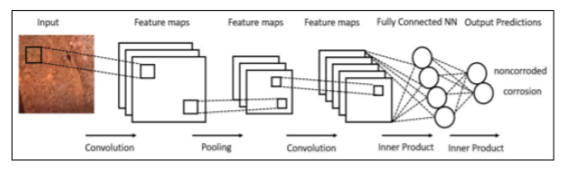

Figure 2.4: Overview of a convolutional neural networks (CNN) architecture

Convolution layers are the means by which a CNN extracts features from an input image. Pooling layers of CNNs are used to down sample the data to decrease the computational costs of a network. Dropout layer. Dropout layers are used to prevent over fitting.

**2.5 Realtime Metal inspection for surface and dimensional defect detection using image processing techniques [5]**

Quality control is a very important process in any manufacturing industry. Quality control is tedious and time- consuming if it is done by human experts. An automated vision system can significantly improve the quality control process both in terms of speed and accuracy. This paper proposes methods for quality control in the metal industry by finding and classifying defects in the metals so that defective metals should not be included with the non-defected metal object. The defect finding in this paper includes major surface defects and dimensional defects associated with the metal object as these defects play a major role to ensure the quality of metal object. In the proposed method, surface defects such as cracks, pinholes, corrosion along with dimensional defects in metals are obtained by different image processing techniques by taking images of the metal object in real-time using a pi camera and further processing it on the raspberry pi.

**Architecture:**

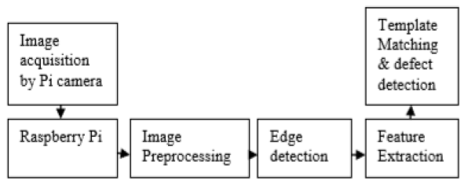

Figure 2.5: Real Time Metal Inspection for Surface and Dimensional Defect Detection

The method involves findings of the dimensional defects and major surface defects like cracks, pinholes and corrosion. The first approach used mathematical morphology and watershed segmentation. The second method makes use of mathematical morphology and bottom-hat filtering. The canny edge detection method is used for edge detection operator that uses a multi -stage algorithm to detect a wide range of edges in images. Contour method is used for calculating feature area, a region of interest and locating the defects in the image.

**2.6 Detection of rust defects on steel bridge coatings via digital image recognition. [6]**

One of the major expenses for steel structures is the anti-corrosion maintenance tasks. The maintenance of a steel structure depends on regular inspections, and visual inspections are often adopted in Taiwan. Using the naked eye to determine the rusted area percentage greatly depends on the experience of the inspector, resulting in subjective results. As an alternative, an algorithm consisting of three different approaches is proposed to automatically process images. The Hue percentage and coefficient of variation (COV) of the grey levels are used to divide images into three groups in which each group is assessed using a specific recognition technique. The three pro- posed techniques are the following: the traditional K-means method in the H component, the double-centre- double-radius (DCDR) algorithm in the Red Green-Blue (RGB) colour space and DCDR in the Hue-Saturation-Intensity (HSI) colour space. Additionally, the Least Square Support Vector Machine (LS-SVM) was adopted to predict the radii in the DCDR approaches. One hundred images, mostly collected outdoors, were used to verify the proposed algorithm. Promising performance was observed, particularly for images with non-uniform illumination.

**Architecture:**

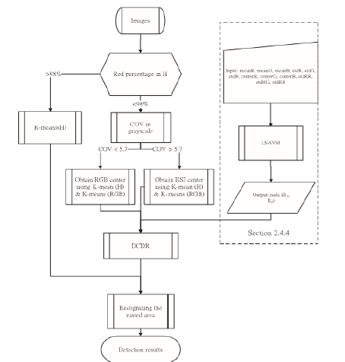

Figure 2.6: Detection of rust defects on steel bridge coatings via digital image recognition

The traditional K-means method in the H component. The double-centre-double-radius (DCDR) algorithm in the Red-Green-Blue (RGB) colour space. DCDR in the Hue-Saturation-Intensity (HSI) colour space. The least square Support Vector Machine (LS-SVM) was adopted to predict the radii in the DCDR approaches

**2.7 Pitting corrosion valuation by computer image processing [7]**

Pitting is one of the most insidious forms of corrosion. It can cause failure by perforation while producing only a small weight loss on the metal. Also, pits are generally small and often remain undetected. A small number of isolated pits on a generally non-corroded surface are easily overlooked. A large number of very small pits on a generally non-corroded surface may not be detected by simple visual examination, or their potential for damage may be underestimated.

Preparation and digitalization of the sample. A specimen of AISI 304L stainless steel with the dimensions of 25 × 60 × 1 ram. was electronically polished in a solution containing 40 ~o H2SO4 and 60 ~ HsPO4. The electrical DC potential was 10V. After polishing the specimen, it was subjected to a corrosive water solution media containing 10~ FeCI3, at a temperature of 50°C for 20 min. The specimen was severely corroded by this treatment. The corrosion attack was identified as high-density pitting corrosion.

Computer processing procedure is the first step in the processing procedure was to ascribe a threshold to the digitized picture, assigning a "zero" to each bright picture element and a "one" to each dark picture element. The threshold between bright picture elements belonging to the background and dark picture elements belonging to pits was selected manually.

**2.8 Image Enhancement Based on Software Filter Optimization for Corrosion Inspection [8]**

This paper is focusing on corrosion inspection using image. Inspection which have particularly challenging environmental conditions and characteristics, increase the complexity of the inspection operation. By using software image filter to enhance the image data, it is believed that the object recognition technique will be able to analyze the image data accurately. A few software filters have been identified in this work. Therefore, in order to obtain suitable software image filter, neural network is used for optimization. The simulations result shows corrosion defect image can be enhanced using a combination of features based image enhancement filters, with regards the corrosion data is able to acquire for recognition process.

**Architecture:**

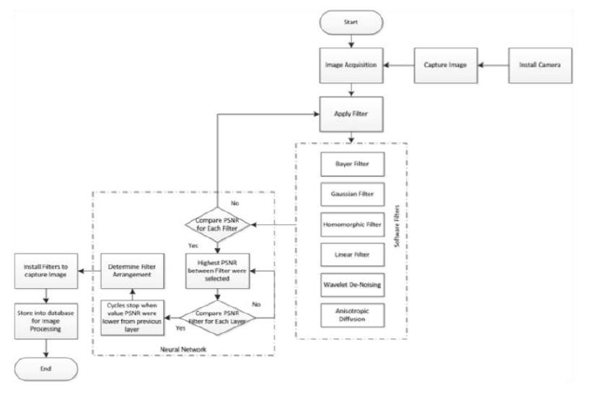

Figure 2.7: Image Enhancement Optimization for corrosion defect

Image Enhancement Filter: The image enhancement filters used in this study emphasizes on image features that are characteristic of surface defects created due to corrosion. Image Error Measurement: Mean Square Error (MSE) and Peak Signal to Noise Ratio (PSNR) are the two error metrics used to compare image compression quality. The MSE represents the cumulative squared error between the compressed and the original image, whereas PSNR represents a measure of the peak error. Optimization - Neural Network: artificial neural network is used for optimizing the image enhancement filter algorithm. As network representation provides such powerful visual and conceptual aid for portraying the relationship between the components or tools of systems that it is used in virtually every field of scientific, social, and economic endeavour.

**2.9 The corroded defect rating system of coating material based on computer vision [9]**

This paper presents a method based on computer vision. To get the information of material corroded defects, the improved watershed segmentation method is used to eliminate over-segmentation. For the processed image information, the parameter will be measured, and with the use of computer query technology, the information of the material corroded defects will be searched and contrasted to reach the function of machine rating.

**Architecture:**

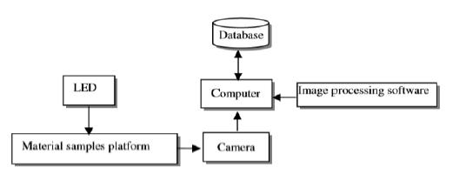

Figure 2.8: Corrode defect of costing material using Computer Vision System

This paper presents a method based on computer vision. To get the information of material corroded defects, the improved watershed segmentation method is used to eliminate over-segmentation. For the processed image information, the parameter will be measured, and with the use of computer query technology, the information of the material corroded defects will be searched and contrasted to reach the function of machine rating.

**2.10. On the evaluation of texture and color features for non-destructive corrosion detection [10]**

In this paper, a methodology for automatic corrosion detection in digital images of carbon steel storage tanks and pipelines from a petroleum refinery. This new approach focuses on color and texture descriptors to accomplish corroded and non-corroded surface area discrimination. The performance of the proposed corrosion descriptors is evaluated by using Fisher linear discriminant analysis (FLDA)

**Architecture:**

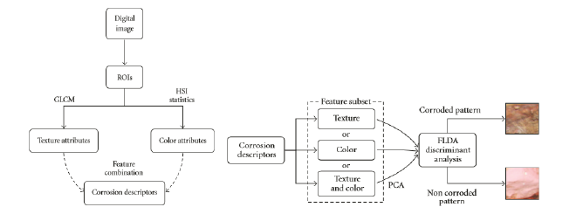

Figure 2.9: Evaluation of Texture and Color Features for Non-destructive Corrosion Detection

A methodology for automatic corrosion detection in digital images of carbon steel storage tanks and pipelines from a petroleum refinery. This new approach focuses on color and texture descriptors to accomplish corroded and non-corroded surface area discrimination. The performance of the proposed corrosion descriptors is evaluated by using Fisher linear discriminant analysis (FLDA).